: 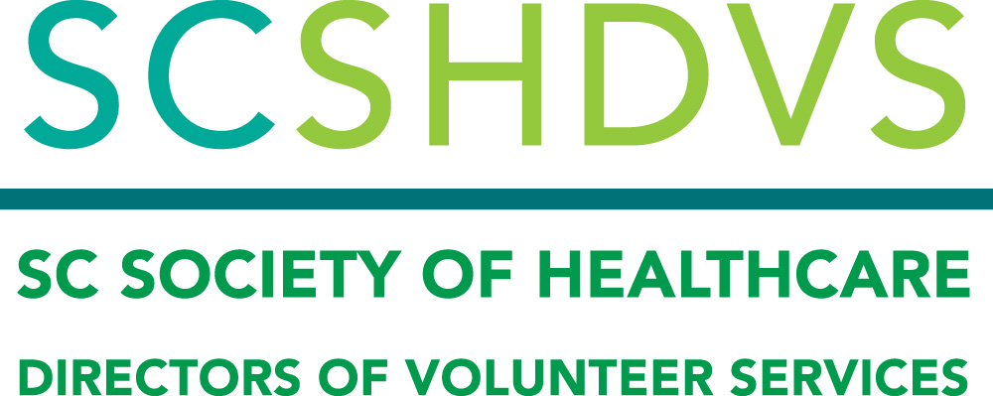

South Carolina Society of Healthcare Directors of Volunteer Services
2021 Virtual Spring Meeting
Tuesday, May 4, 2021 10 a.m. – 2:30 p.m.

10:00- 10:10 Welcome
Linda Boone, President SCSHDVS, McLeod Regional Medical Center

10:10 – 11:00 Business Meeting

11:00 – Noon Roundtable Discussion

Noon – 1:00 Lunch and Networking

1:00 – 2:30 The Empowered Volunteer Leader
Eileen McConville, MBA, CAVS, Vision Volunteering, LLC

2:30 Adjourn
Bio:
Eileen McConville served as Director of Volunteer & Auxiliary Services at New Hanover Regional Medical Center for 15 years. She was responsible for oversight of 900 active volunteers and 50 paid staff in a 728-bed public hospital. Prior to her work in volunteer management, Eileen served as Director of Marketing at NHRMC and has a total of 30 years’ experience in hospital operations.
In 2018, Eileen formed Vision Volunteering, LLC. This consulting company is ready to assist volunteer leaders advance their practice and strengthen the volunteer impact at their organizations. Eileen served as AHVRP’s presenter of their 6-part series, “Principles of Volunteer Resource Management.” Eileen received her MBA from UNC-Wilmington and is a Certified Administrator of Volunteer Services.

General Information:
Register Online
To register & view the agenda, visit the SCHA web calendar, https://scha.org/events/ select this meeting, and click “Register Online”. A registration and payment confirmation will be emailed directly to you once you complete the registration process.
You will receive an email from Kim Wooten, kwooten@scha.org with the webinar login information a couple of days before the event. Please do not share the link, as it is unique to your registration.
Registration & Fees:
No registration fee for current paid members, $30 for non-members.
If you are not a current member, click here to join or renew your membership
Online registration will close 3 business days prior to the meeting Persons wishing to register after that time must email Kim Wooten at kwooten@scha.org

